Appendix (additional files)
Additional file 1:

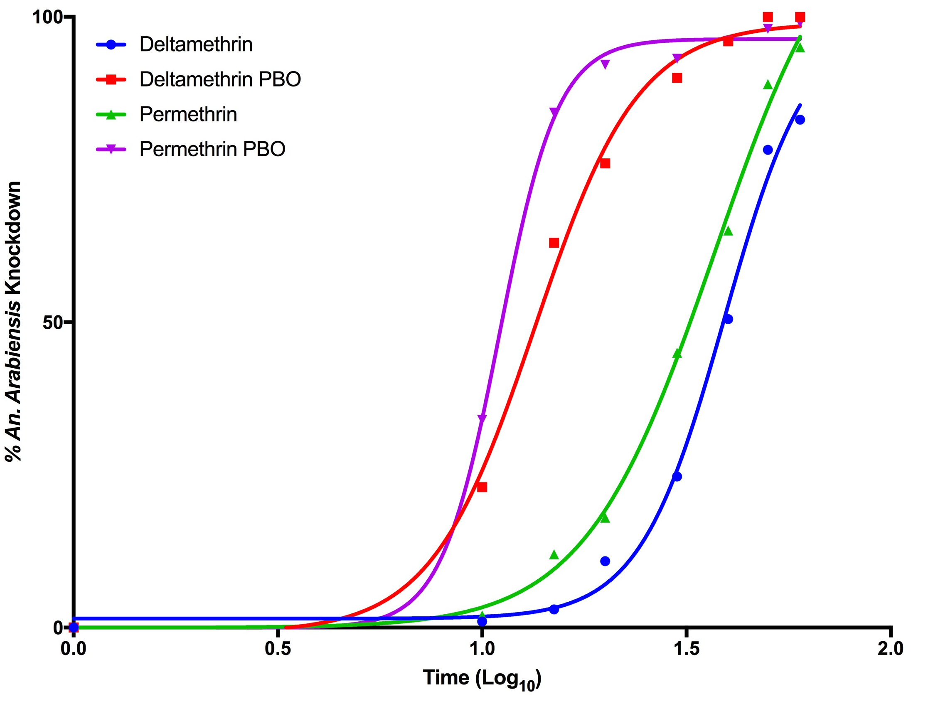
Figure 3: Temporal (log₁₀ minutes) percentage knockdown of Adult female An. arabiensis mosquitoes (from Moroto district, Uganda) by various formulations of pyrethroids.

